**Structural Components of GUI**

a. Video Feed

i. Control Static Imaging

ii. This will display the playing field to the operator.

iii. It will be used for manual control and calibration

b. Setup/Configuration

i. Twitter/Team Name

ii. Link Light- used to confirm communication with Raspberry Pi via IP.

iii. Start Button – This will let the game server know we have initialized the game

iv. Stop Button – This will be used to stop the game if have any problems or are asked to

by magistrate.

v. Shell Button – will be a portal to the shell format of the game.

vi. Twitter Feed – will display what is being posted on Twitter.

c. Game View

i. Game Status

ii. Time display – will display the time since the game has been started.

iii. Score display – will display the score of the player up to that point.

iv. Shots left display – will let the player know how many shots remain.

d. Target View

i. Target Atrributes/States

ii. Feed from Server Text Box – all the targets info will be presented here and other

updates coming in from the server will be updated.

e. Missile Launcher View

i. Status

ii. Direction buttons – used to manually move the turret

iii. Fire button – will be used to fire the missiles foam darts.

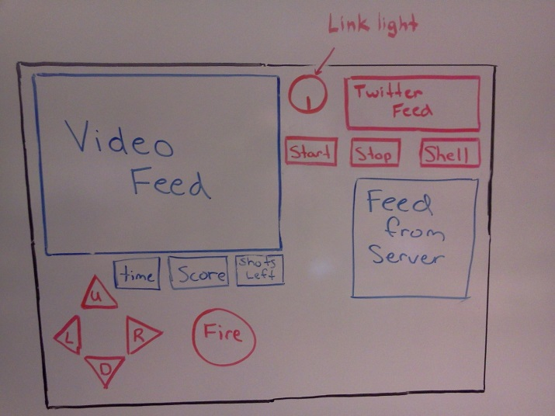

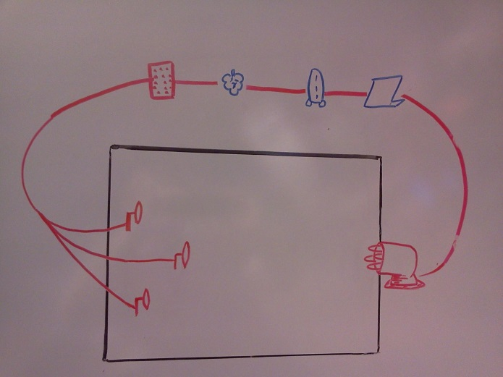

**User Interaction and Behavior with GUI**

a. Starting a Game

i. To start a game we first need to validate that we have a link to the game server by looking at link light.

ii. To interpret feed from server with information of game to be played.

iii. Do configurations based on game that is to be played.

iv. Push the start button which will in turn let the game server know we have initialized a game.

b. Stopping a Game

i. To stop a game we simple push the stop button on the upper right hand corner.

ii. There is no continue button so the user must now refer to starting a game to begin a new game.

c. Changing a Game

i. User will click on Stop, to stop a game. He or she will then refer to starting a game-which includes clicking again on the Start button.

d. Manual Control of Turret

i. When the game entitles it the user will use the Up, Down, Left, Right arrows to adjust their aim of targets.

ii. The user will use the big button in the bottom of the window labeled fire to fire one missile at a time. He or she will click on the button and wait to see if they hit a target.

e. Automated Turret Control

i. When an automated game is entered the user will simple push start and wait until the turret has acquired all enemy targets and fired upon them.

f. Switching between Shell and GUI

i. To switch between the console and user will simply click on the button labeled shell.

ii. This in turn will redirect them to the command line interface.

iii. From here the user will be able to go back to the GUI interface.

**Formal User Cases**

UserID = 1

Name = Starting a Game

Pre-Condition = GameClient is connected to the GameServer, Game/ Target information is available in our Game Text Area, Directional buttons have been used the aim our Dream Cheeky based on our Web Camera view. Ready to attack target

Normal Steps:

1. Link with Server.

2. Verify Game type.

3. Click on start buton.

4. Calibrate missile launcher.

5. If game is manual- control directional buttons until we have a firing position.

6. Click Fire button.

7. Continue until you have ran out of bullets

Alternative Steps:

1. if Link with server not achieved troubleshoot Link.

2. if no detail from GameServer verify with magistrate that Game info has been setup.

3. If missile Launcher is non-responsive power cycle and verify GameClient can communicate.

4. If directional buttons don't work follow step 3.

5. If fire button doesn't work, verify missile is not stuck.

Post-Conditions

1. Game is in play mode (ready to play specified game).

UserID = 2

Name = Stopping a Game

Pre-Condition: the game is in play mode and some problem has arised.

Normal Steps:

1. User presses the Stop button.

2. Game is stopped and reset back to the normal state of the game.

3. Game is ready for new or same game type.

Alternative Steps:

1. If game does not stop user will have to exit the application and reenter the program.

2. If game is stopped but not reset user will have to again exit the application and reenter the program.

Post-Condition:

1. Game is ended we are back in the start game mode.

UserID = 3

Name = Changing a game

Pre-Condition: the game is over or the user wants to start a new game.

Normal Steps:

1. User presses the Stop button.

2. User waits for game to stop.

3. User will then click the start button which will begin a new game type.

Alternative Steps:

1. If game doesn’t stop user will have to exit the application and reenter the program.

Post-Condition:

1. Game is now in the start game mode.

UserID = 4

Name = Manual Control of Turret

Pre-Condition: Game is in play mode.

Normal Steps:

1. User will simply click on the start button to initiate the game.

2. Updates will pop up on the twitter feed.

3. The shots left will be updated as well as the score and time.

4. The camera feed will then begin uploading.

5. All shots will be fired by user.

6. Game will then finish.

Alternative Steps:

1. If game doesn’t start then just exit the program and restart it.

2. If camera fails to upload image make sure cables are connected.

Post-Condition:

1. Game is now in the start game mode.

UserID = 5

Name = Automated Turret

Pre-Condition: Game is in play mode

Normal Steps:

1. User will simply click on the start button to initiate the game.

2. Updates will pop up on the twitter feed.

3. The shots left will be updated as well as the score and time.

4. The camera feed will then begin uploading.

5. All shots will be fired automatic.

6. Game will then finish.

Alternative Steps:

1. If game doesn’t start then just exit the program and restart it.

2. If camera fails to upload image make sure cables are connected.

Post-Condition:

1. Game is now in the start game mode.

UserID = 6

Name= Switching to Shell

Pre-Condition: User is in the GUI

Normal Steps:

1. User will click on the shell button to change to the command line interface.

2. User will continue to use command line or transfer back to the GUI.

Alternative Steps:

1. If game doesn’t change to the command line when shell button is clicked then the game should be restarted and the shell button can be tried again. If problem continues then user will have no other choice but to continue in GUI mode.

Post-Condition:

1. Game is now in command line interface mode.